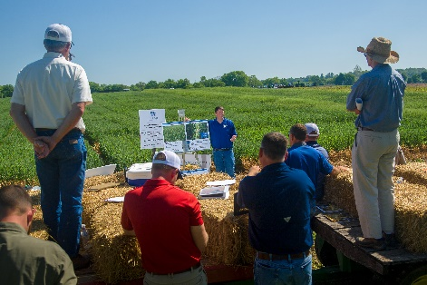
Ballard County Ag Newsletter
April 2023
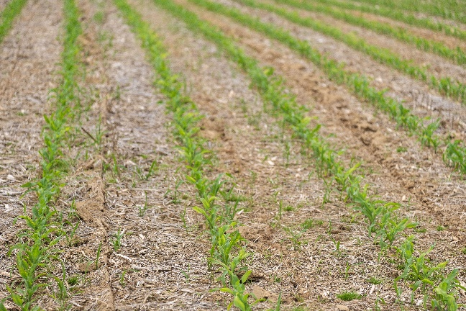
Wheat Field Day 2022

Corn is coming up. I saw several fields of corn just poking through the soil this morning on my way to work. So far we have had a very nice planting season with one of the largest windows to plant crops in early April that I can remember. Hopefully, it took much of the pressure off as at least 50 % of the corn and a large percentage of the single crop soybeans were planted last week.

While early planting does not guarantee high yields, the odds are much better for early planted crops to yield better than late planted crops. We have a good start. Wheat is just starting to head out and our weather from here until June will determine what kind of wheat crop we have. I think the potential is still there for an outstanding crop.

Wheat Field Day

Cooperative Extension Service
Ballard County Extension Office
110 Broadway PO Box 237
LaCenter, Kentucky 42056-0237
Phone: 270-665-9118
Email: tmiller@uky.edu
The 2023 Wheat Field Day will be held at the Research and Education Center at Princeton on May 9th. Registration begins at 8:00 am and the meeting will start at 9:00. This will be the first large scale field day in several years due to COVID forcing everything on-line. Then all the damage from the tornado at the Princeton Station impacted last year’s field day. If you have not been to the research farm since the tornado, it is almost unrecognizable. All the buildings are gone. There are some portable replacement trailers with offices and some temporary storage structures. Despite the challenges, field work has gone on with all the land still being used for either Beef, Crop or Horticulture experiments.
Topics to be covered at the field day include Wheat Market Outlook with new Ag Economic Extension Marketing Specialist Grant Gardner. There will be a stop for Drone Regulations, Applications and Economics and a stop on the Battle between Wheat and the Weather. There will be the usual stop with the latest on Fusarium Head Blight, our most damaging disease in wheat. The latest in Wheat Agronomics will be discussed as will the latest from the insect side. Finally, a walkthrough of the extensive variety trial, where you can see new varieties and experimental varieties all compared to old standby varieties.
The program will finish by noon with a lunch sponsored by the Ky Small Grain Grower’s Association where Neil Denton serves on the Board of Directors. The address of the farm is 1205 Hopkinsville St, Princeton, KY 42445. Look forward to seeing you there.
Scan here for more event info on kygrains.info!

CAIP Deadline Fast Approaching

You have approximately 1 month to get all your paperwork in to get reimbursed through the CAIP Program. The final deadline is Friday May 26th. When you bring your paperwork it would be a good

idea to call the office first to make sure I am there, our number is 270-665-9118. This time of year I never know when I’m going to get called out to look at a problem but if I know you are coming I can make arrangements. You need the producer form, receipts and cancelled checks and we will work on the education form together.

Performance of Asymbiotic N-fixing Products

One of the new product categories on the market are products that claim they can replace part of your nitrogen with a seed treatment or a sprayed on product that helps the plants fix nitrogen. Twelve universities across the northern corn belt took a look at some of the products last season, including UK, Illinois, Missouri, Ohio State, Purdue and several others. The publication just came out and you can find it online or I can print you a copy. Products included Envita, Utrisha, ProvenN and Proven N40 and MicroAZ-ST. These products claim that they can replace up to 50 Lbs of N. Cut your N rate by 50 Lbs and these products will replace it.
You would expect that if these products work, they would work at lower N rates and show a yield advantage. While all the trials were not duplicates, all had a low, medium and high N rate with and without the products added. Sixty one trials were conducted across these states and in all trials the crops did respond to added N fertilizer. Every state was different in the maximum N response. Crops respond to N until you get enough, then they don’t respond anymore. That is why we always recommend a little more than you will need to make sure there is enough. In 2 of the 61 trials, there was a positive yield response with these products, which means 59 out of 61 times it did not work. I fully expect that somewhere in the future there will be a product in this category that does work but we are not there yet. Just be skeptical when you hear some of the claims made that promise to make something more efficient and you can cut your rate. Also be very wary of some products that claim you can just use 5 gallons of liquid to replace fertilizer. It could work with a micronutrient but not with any other nutrient you need in a large amount.
Scan for Publication for Asymbiotic N-
fixing products

Timely Tips

Dr. Les Anderson, Beef Extension Professor, University of Kentucky

Spring Calving Cow Herd

- Watch cows and calves closely. Work hard to save every calf (you can cull/sell them later). Calves can be identified while they are young and easy to handle. Commercial male calves should be castrated and implanted. Registered calves should be weighed at birth.
- Cows that have calved need to be on an adequate nutritional level to rebreed. Increase their feed after calving. Don’t let them lose body condition. Keep feeding them until pastures are adequate.
- Don’t “rush to grass” although it can be really tempting. Be sure that grass has accumulated enough growth to support the cow’s nutritional needs before depending solely upon it. Cows may walk the pastures looking for green grass instead of eating dry feed. This lush, watery grass is not adequate to support them. Keep them consuming dry feed until sufficient grass is available to sustain body condition. We’ve spent too much money keeping them in good condition to lose it now!
- Prevent grass tetany! Provide magnesium in the mineral mix until daytime temperatures are consistently above 60ºF. Mineral supplement should be available at all times and contain a minimum of about 14 percent magnesium. Make sure that your mineral mix also contains adequate selenium, copper and zinc. You can ask your feed dealer about the UK Beef IRM High Magnesium Mineral.
- Make final selection of heifer replacements. Strongly consider vaccinating with a modified-live BVD vaccine.
- Purchase replacement bulls at least 30 days prior to the start of the breeding season. Have herd bulls evaluated for breeding soundness (10-20% of bulls are questionable or unsatisfactory breeders). Get all bulls in proper condition (BCS 6) for breeding.
- If you are going to use artificial insemination and/or estrous synchronization, make plans now and order needed supplies, semen, and schedule a technician.
- Prebreeding or "turn-out" working is usually scheduled for late April or May - between the end of calving season and before the start of the breeding season (while cows are open). Consult your veterinarian about vaccines and health products your herd needs. Make arrangements now for products needed and have handling facilities in good working order. Dehorn commercial calves before going to pasture.

Fall Calving Cow Herd

- Pregnancy check cows now and cull open ones at weaning especially if the open cows are older than 5 years of age.
- Re-implant feeders.
- Consult with your veterinarian about a preweaning working of the herd.
- You may let calves creep-graze wheat or rye, if it is available. Calves will benefit from extra feed until spring grass appears.
- Plan marketing strategy for feeder calves.

Stockers

- Don't go to pastures too soon, give plants some growing time. Then stock at two to three times the July rate and rotate rapidly.
- "Condition" purchased calves prior to grazing. They should be processed and fed a conditioning diet prior to being placed on pasture. You can also use this time to introduce them to electric fences which are used in rotational grazing.
- Provide a good mineral supplement which contains a rumen modifier (Rumensin, Bovatec, etc.) along with adequate levels of copper and selenium.

General

- We’ve made a muddy mess this winter, so be prepared to reseed bare spots. Our forage group has some excellent information on restoring heavily traffic areas.
- Make plans to improve hay feeding areas to avoid muddy conditions like we have faced this winter. Consider geotextile fabric with gravel or concrete feeding pads.
- Prepare for the grazing season. Check fences and make necessary repairs. Check your corral, too.
- Get everything ready to make high quality hay in May! Have equipment serviced and spare parts on hand. Order baler twine now. Be prepared to harvest an adequate supply of hay when you have the opportunity. Re-supply the extra hay that you fed out of the barn. This past winter caused most producers to exhaust their hay supply, so it’s time to re-stock.
- Plan now for fly control ... decide what fly control program that you will use but don't put insecticide eartags on cattle until fly population appears.

Beef Quality and Care Assurance Certification Free in April
Dr. Darrh Bullock and Kevin Laurent, Beef Extension Specialists, University of Kentucky

The Beef Quality and Care Assurance (BQCA) certification is being offered for free in April and September 2023 by the University of Kentucky (UK) and the Kentucky Beef (KBN). The normal cost of the training is $5 for in-person and $10 for online training.
Becky Thompson of KBN states “The Kentucky BQCA program takes national BQA practices one step further to provide a holistic program for Kentucky producers, by adding cattle handling and animal care components to the training modules. Educational modules provide the best management practices for handling cattle and providing for their well-being, in addition to training on the core principles of BQA.”.
This program is run jointly by UK and KBN. Producers interested in taking advantage of this opportunity can visit www.kybeefnetwork.com or https://afs.ca.uky.edu/content/bqca-training-online to access the online training platform or contact your county extension office for in-person training opportunities.Additionally, we will be conducting a BQCA Chute Side Training (qualifies for certification) at Blue Grass Stockyards April 20 with registration and lunch starting at 11:30am EDT. Things should be wrapped up by about 3:30pm. Pre-registration is required and can be done by calling the Kentucky Cattlemen’s Association office at (859) 278-0899 or email kbn@kycattle.org. Only 60 spots are available.
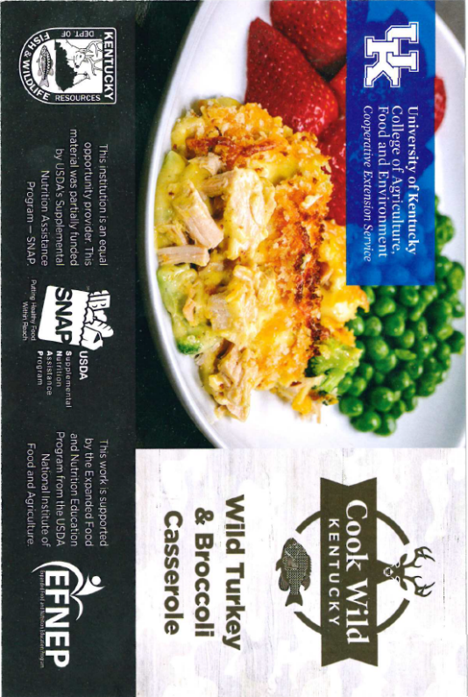

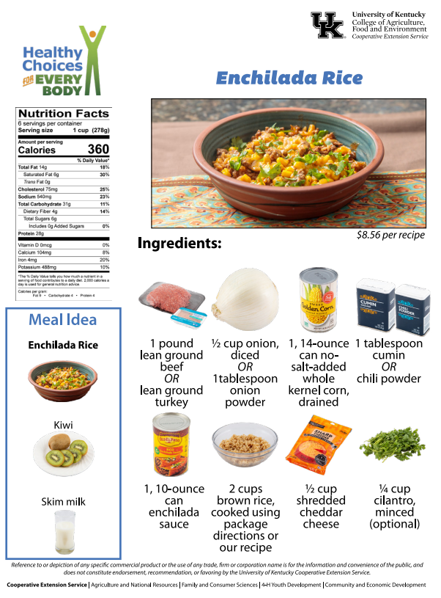

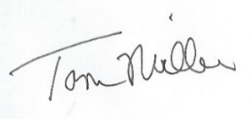
Released by

County Extension Agent for Agriculture and Natural Resources
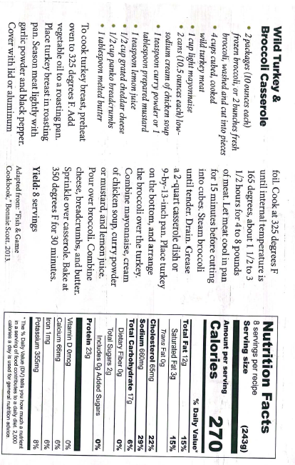

Enchilada Rice Directions.

Prepare 2 cups of brown rice or use leftover rice.
Dice 1/2 cup onion using a knife and cutting board.
Heat a large skillet to medium heat, and add 1 pound of ground beef and 1/2 cup diced onion.
After handling the raw ground beef, wash hands with warm water and soap, scrubbing for at least 20 seconds.
Break the meat up with a mixing spoon and move around the pan. Be sure it is cooked to an internal temperature of 165 degrees F (about 10 minutes).
Using a colander, drain the mixture, being sure not to pour the fat down the sink. Return the beef and onion mixture back to the skillet. Throw grease in the trash after it has cooled.
Open and drain the can of corn.
Add drained corn, 1 tablespoon cumin or chili powder, and 1 can enchilada sauce to the skillet. Stir well. Simmer for 10 minutes.
If using cilantro, rinse under water to get rid of any dirt. While the beef mixture is simmering, chop cilantro.
Turn off heat and remove skillet. Stir in 2 cups cooked brown rice.
Add 1/2 cup shredded cheese; cover with aluminum foil and let sit for 5 minutes. Sprinkle cilantro on top before serving.
Refrigerate leftovers within 2 hours. Eat within 3-4 days.

360 calories; 14 fat; 6g saturated fat; 0g trans fat; 75mg cholesterol; 540mg sodium; 31g carbohydrate; 4g fiber; 6g sugar; 0g added sugar; 28g protein; 0% Daily Value of vitamin D; 8% Daily Value of calcium; 20% Daily Value of iron; 10% Daily Value of potassium.

