Ballard County Ag Newsletter
March 2023
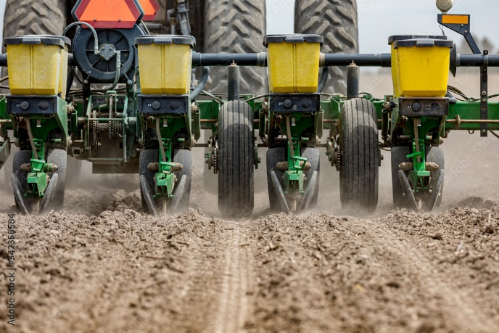
The Calm before the Storm
As I write this in the middle of March, temperatures have turned colder. This may be a good thing for slowing the wheat crop down a little. I fear for fruit trees that were in bloom as there may be some cold damage to peaches and other fruits.
I am still very optimistic about the wheat crop. There is some concern for cold damage, but even in years where there has been cold damage in other parts of the state, we have seen little damage in far Western Kentucky.

Over the next 6 weeks an unbelievable amount of work needs to be done. From finishing up wheat, applying N and other fertilizers, burndowns and corn and bean planting, these next 6 weeks will either set us up for another good year or be the cause of a lot of worry and catch up.
I know many of you want to go on and plant some beans. I can’t argue against it, seeing some of the results from farther north, but the most important thing to remember is to not let anything interfere with getting the corn planted on time. Two years ago early beans had an advantage but this past year, not so much. We can make 60 bushel double crop beans planted in June. Our best corn tends to come
Cooperative Extension Service
Ballard County Extension Office
110 Broadway PO Box 237
LaCenter, Kentucky 42056-0237
Phone: 270-665-9118
Email: tmiller@uky.edu
in the last 2 weeks of April and the first week of May. Soybeans will forgive almost all of your mistakes while Corn will not forgive hardly any.

CAIP Program Reminders

I am slowly getting receipts and checks back out for the CAIP program. Remember the last day to accept receipts is the Friday before Memorial Day, May 26. The biggest problem is cancelled checks. We need a good receipt and either a cancelled check or a credit card statement showing you paid the receipt. No cash. Just give me call and we can easily fulfill the education requirement.

Private Pesticide Applicator Renewal

Check your yellow private applicator card to see if it has expired. Currently renewals are good for three years. Several big changes have been made to Commercial applicators and I expect these changes to trickle down to Private applicators in the coming years. I have tried to contact all of the expired cardholders in Ballard County. If you got your card somewhere else I can’t look at those records. It’s not hard to do, just be sure and give me a call to make sure I’m in the office as it is not something that the others can help you with.

What is pH and why you should care

When you get a soil test back, the most important numbers on the page are the pH of your soil. The first number, soil pH tells us where your soil is on the pH scale. For optimum crop production in KY that number needs to be somewhere between 6 and 7. Buffer pH will also be listed and this is a calculation for how much lime it will actually take to change the pH of your soil.
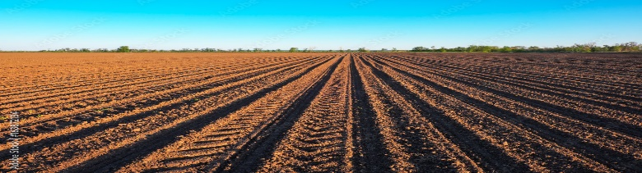

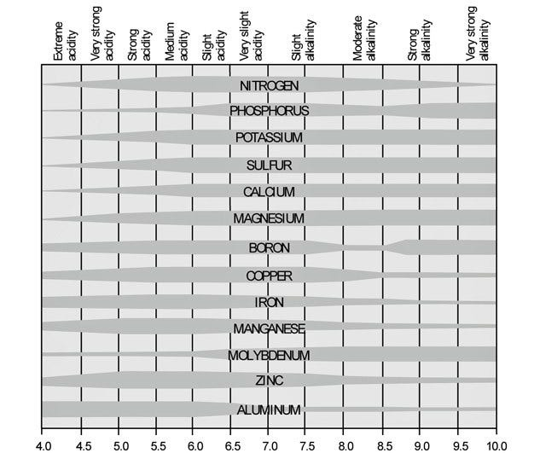
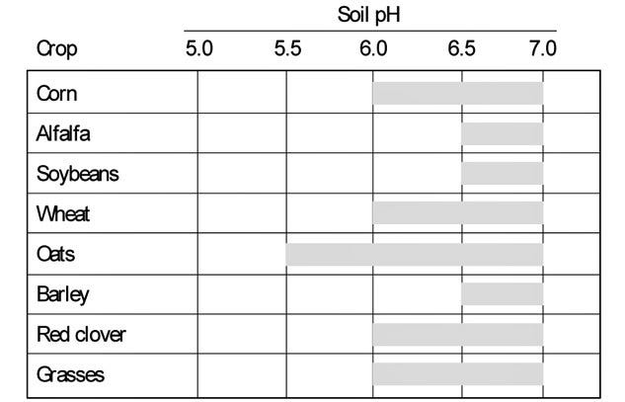
Table 1 Favorable pH ranges for common crops ( from Penn State Soil Acidity and Ag Lime Website)

Soil acidity is a natural process that occurs over time. An uncropped soil covered in trees in our area would probably have a pH around 5, not very suitable to good crop production. We also contribute to soil acidity by using fertilizer, most notably nitrogen and sulfur. It’s a catch 22. We have to have the nitrogen to grow good corn and wheat but we are lowering our pH when we use it. I found some interesting data on Penn State’s website that gave how much lime it took to neutralize 1 lb. of nitrogen from various sources. It takes 3 lbs of lime to neutralize 1 lb of N from our main sources, Ammonium Nitrate, Urea, UAN and Anhydrous Ammonia. It take 5.3 lbs of lime for 1 lb. of N from DAP, we get much less N from this source. It takes 7 lbs for ammonium sulfate and MAP.
pH is the driver for nutrient availability in your soil. When your pH is below 6 or above 7, almost all nutrients become less available to the plant. You can have plenty out there but if the pH is wrong, the soil chemistry won’t work right and the plant can’t get to the nutrients to use them. Some micronutrients become much more available with a lower pH and you risk getting too much. I use to see Manganese Toxicity in Tobacco from a low pH. This nutrient availability is so important that I would almost recommend skipping a year of P and K fertility to spend the money on lime to get the pH correct.
The main reason that I am talking about Lime and pH is that there are some companies out there selling a liquid Calcium product claiming it can raise the pH quicker than lime. We tested several of them compared to ag lime and pelletized lime both in the field and in the greenhouse. Liquid Calcium had no effect on pH, both the ag lime and the pelletized lime worked like they were supposed to and raised the pH. Think about your late night heartburn and acid stomach. You take a Tums ( Calcium Carbonate) and the carbonate part of the Tums neutralizes stomach acid. The Calcium is just a carrier. Guess what ag lime is, Calcium
Figure 2. How soil pH affects availability of plant nutrients and aluminum. ( Also Penn State Website

Carbonate, very similar to a Tums. The carbonate part neutralizes the soil acid, the calcium is just a carrier. These products can supply calcium but they do nothing help pH. If you keep the pH correct with Ag Lime you will have no concerns with Calcium.

Forage Timely Tips: March
- Continue pasture renovation by no-tilling seeding legumes.
- Place small seed at 1/4 to 1/2 inch deep and check depth several times during planting; slow down for more precise seeding.
- Continue feeding hay until adequate forage exists in the pasture for grazing.
- Spring seeding of grasses should be done in early to mid-March (but fall is preferred)
- Begin smoothing and re-seeding hay feeding and heavy traffic areas.
- Graze pastures overseeded with clover to reduce competition from existing grasses (Pull off before grazing new clover plants).
- Provide free choice high-magnesium mineral to prevent grass tetany on lush spring growth.

Timely Tips
Dr. Les Anderson, Beef Extension Professor, University of Kentucky

Spring-Calving Cows

- Observe spring-calving cows closely. Check cows at least twice daily and first-calf heifers more frequently than that. Be ready to assist those not making progress after 1 to 2 hours of hard labor. Chilled calves should be dried and warmed as soon as possible.
- See that each calf gets colostrum within an hour of birth or administer colostrum (or a commercial colostrum replacement) with an esophageal feeder, if needed.
- Identify calves with eartags and/or tattoos while calves are young and easy to handle and record birthdate and Dam ID. Commercial male calves should be castrated and implanted as soon as possible. Registered calves should be weighed in the first 24 hours.
- Separate cows that have calved and increase their feed. Energy supplementation to cows receiving hay is necessary to prepare them for rebreeding. For example, a 1250 lb cow giving 25 lb/day of milk would need about 25 lb of fescue hay and 5 lb of concentrate daily to maintain condition. If you need to go from a condition score of 4 to 5, you will need to add about 2 more lb of concentrate. Cows must be in good condition to conceive early in the upcoming breeding season.
- Watch for calf scours! If scours become a problem, move cows that have not calved to a clean pasture. Be prepared to give fluids to scouring calves that become dehydrated. Consult your veterinarian for advice and send fecal samples to diagnostic lab to determine which drug therapy will be most effective. Try to avoid feeding hay in excessively muddy areas to avoid contamination of the dams’ udders.
- Continue grass tetany prevention. Be sure that the mineral mix contains high levels (~15%) of magnesium and that cows consume adequate amounts. You can feed the UK Beef IRM High Magnesium mineral.
- Plan to vaccinate calves for clostridial diseases (Blackleg, Malignant Edema) as soon as possible. You might choose to do this at the prebreeding working in late April or early May.
- Obtain yearling measurements on bulls and heifers this month (weight, height, pelvic area, scrotal circumference, ultrasound data, etc.) if needed for special sales. Heifers should be on target to be cycling by the start of the breeding season.
- Prepare bulls for the breeding season. Increase feed if necessary to have bulls in adequate condition for breeding. Obtain Breeding Soundness Evaluation (BSE) on bulls, even if they were checked last breeding season. Only use bulls that pass the BSE.
- Finalize plans for your spring breeding program. Purchase new bulls at least 30 days before the breeding. Order semen now, if using artificial insemination.

Fall-Calving Cows

- Bull(s) should be away from the cows now!
- Plan to pregnancy check cows soon. You can also blood test for pregnancy as early as 30 days after bull removal.
- Creep feed calves with grain, by-products, or high-quality forage. Calves will not make satisfactory gains on the dam’s milk alone after about 4 mos. of age – since there isn’t much pasture in March, fall calves need supplemental nutrition. Consider creep grazing on wheat pasture, if available. Calves can also be early weaned. Be sure that feed bunks are low enough that calves can eat with the cows.
- Calves intended for feeders should be implanted.
- Consider adding weight and selling your fall calves as “heavy” feeder calves. Keep them gaining!

General

- Repair fences, equipment, and handling facilities.
- If you have a dry, sunny day, use chain-link harrow to spread manure in areas where cattle have overwintered. This may be done in conjunction with renovation.
- Renovation and fertilization of pastures should be completed.
- Start thistle control. They can be a severe problem in Kentucky pastures. Chemical control must be done early to be effective.
- Watch for lice and treat if needed.
Be Opportunistic as a Margin Operator
By: Kenny Burdine, University of Kentucky
While there are always a number of factors that can impact cattle markets, things appear to be setting up well for stocker operations in 2023. First, high feed costs are likely to result in very high value of gain on calves this year. The chart above shows estimated feed cost per lb of gain from Kansas State’s Focus on Feedyards newsletter. Note the estimated cost of gain for January was over $1.45 per lb. And secondly, there is an incredible amount of carry in feeder cattle futures markets. As I write this, the November contract is trading at a $30 premium over March (see chart below, updated from last week). This means that the expectation is for heavy feeder cattle prices to increase throughout the year, which will only add to the value of pounds that are added through growing programs. And we are starting to get a clearer picture of what calf values are going to be this spring.
Astute margin operators are regularly running budgets for their programs. They use the futures market to predict the value of feeder cattle when sold in the future, estimate the cost of growing calves until sale, and use that to determine what can be paid for those calves at placement. In truth, these returns will vary depending on the type of calves that are placed into their programs. Some operators like to place steers, while others prefer to grow heifers. Some producers choose to buy preconditioned calves, while other may choose to buy lighter calves that are fresh off the cow. Others have found niches for buying discounted bull calves, castrating them, and selling them later as feeder steers. The point is that there are a lot of potential programs that may allow for profit to be made.
When calves are placed into a growing program, money can often be made on the “buy”. By that I mean that getting a group of calves placed at an attractive price is a key first step to profitability. Sometimes producers need to look at multiple types of calves to determine where those attractive buying opportunities are. If producers are comfortable placing different types and weights of calves, they should run budgets for multiple systems and take advantage of profit opportunities when they come into view. This flexibility on the type of cattle being placed can allow producers to capitalize on different opportunities available at different times in the market.
Being opportunistic can also pay off when it come to pricing. Once calves are placed into a backgrounding or stocker program, very few things will have a larger impact on profit than what the market does between placement and sale. So, producers should be thinking about ways to manage price risk from the start. Calves are going to be very expensive this spring, which means that stocker operators will have a lot of money at risk from day one. In fact, they will likely have more than 80% of their total costs sunk the day they place those calves. So, producers may also want to be opportunistic about taking advantage of price risk management opportunities. With a fall board above $220 per cwt, the market is offering some pricing that we have not seen in quite some time. Profit opportunities will exist in 2023, but stocker operators need to be opportunistic when the get the chance to place cattle at an attractive margin and take advantage of pricing opportunities as they present themselves.

Released by
County Extension Agent for Agriculture and Natural Resources

