Ballard County Ag Newsletter
November 2023

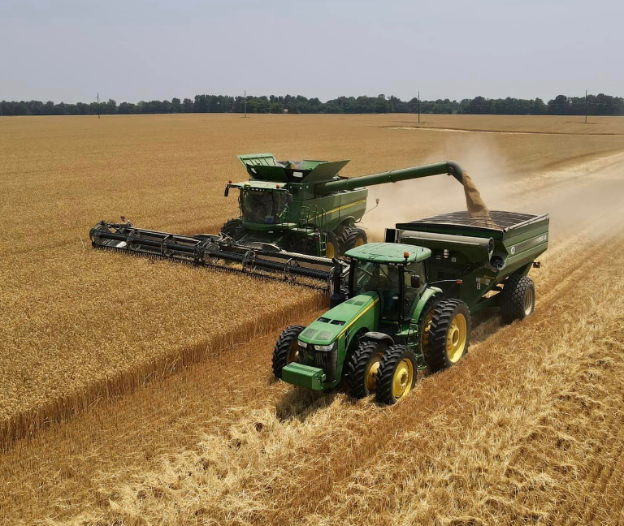
Photo credit: Zoe Dillworth

Harvest is winding down on a year that had a lot of extremes. It was either too wet or too dry, too hot or too cold and not a lot of in-between. The wheat crop started out as too dry last fall. We were cool and wet this spring with a long grain fill due to cooler temperatures and we ended up with the best wheat crop on record.

The corn season began with 2 or 3 distinct planting windows for a smooth start. This produced some of the best, most uniform stands we have ever seen . Hot and dry hurt the first planted corn with some pollination problems. The later planting dates tended to be higher yielding, but all of our corn was hurt to some degree from where we started. Yield range was from about 120 bushels per acre to 225 bushels per acre. Location was the most important

factor. It was dry everywhere but several areas suffered worse.

Early beans were hurt by the dry weather. I have heard a lot of 70’s, a few 80’s and even a couple of 90’s but there were also some 45 bushel beans out there. No major disease problems occurred except a little bit of SDS in a few fields. Double crop beans were a different story. It was extremely dry at planting and stands looked marginal. I thought about replanting my personal beans and probably would have if it had been May instead of June. Then we had the flood and it saved the later beans. Almost every yield I have heard has been 50 or 60 bushels per acre with many over 60. If you put 100 bushel wheat with 60 bushel double crops, it makes up for a down corn year.
Cooperative Extension Service
Ballard County Extension Office
110 Broadway PO Box 237
LaCenter, Kentucky 42056-0237
Phone: 270-665-9118
Email: tmiller@uky.edu

The flood definitely hurt soybeans and some corn in the bottom fields. You cannot be underwater long and not suffer some damage. The mud on the leaves has to cut down on photosynthesis and makes a real mess at harvest. Overall, I would say the flood helped much more than it hurt at the end of the day.

Wheat planting went much better this fall than last year. Although we are still dry, we have had a few little rains, enough to get the wheat up and right now it looks promising.

New Diseases to Watch

Although not brand new, Tar Spot is a disease that is new to us. It has become a real problem in the northern cornbelt. Just a few locations have been found in Kentucky and all of them have been late in the season. It is a disease that tends to thrive in cooler temperatures- daytime highs in the 70’s. It should not be a problem for us until late in the season much like Southern Rust. Although they are complete opposites, Southern Rust from the south and Tar Spot from the north, the same fungicides do a pretty good job on both. In years where either is going to be a problem, the late at tassel fungicide application should protect yield through maturity.

A new soybean disease is red crown rot. It has been located much closer to us in southern Graves County, almost to the Calloway County line. We have had plots in the initial field for several years now and it looks like some of the seed treatment options will do a good job when this disease becomes a problem. I have a friend from college that works in south central Indiana for a Coop and he sent me some pictures where it was really hurting fields in that area. Flat bottoms with really wet soils are affected the worst. It looks much like SDS, with the interveinal chlorosis, but then the leaves tend to fall off the plant where with SDS they hang onto the plant. The real sign is if you pull the plant up, right at the soil level, the stem will be a deep burnt orange color. I sent in plants from several fields where I suspected SDS. I would pull up the plant and thought that looks kind of red. Everything came back as SDS in my samples and I finally went down one afternoon and met Dr Carl Bradley in the Graves location. When we pulled up some plants and I actually saw how red the crown of the plant was, the difference was quite noticeable.

New Farm Bill

The current Farm Bill is about to expire and it is almost assured that nothing new is going to come out this year. There is a resolution currently at work to extend the bill another year. I think that is eventually what will happen. Without an extension, we may lose our crop insurance and that is the most valuable part of the bill for us. Next year is a presidential election so the thinking is that there may not be a new farm bill until after there is a new president with new direction.

If there is an extension, I still feel that you need to keep everything in ARC Co. The only way that PLC is the better choice is if the prices fall completely off the charts. We will have until next spring if they let you make a decision and I will try to keep you informed.
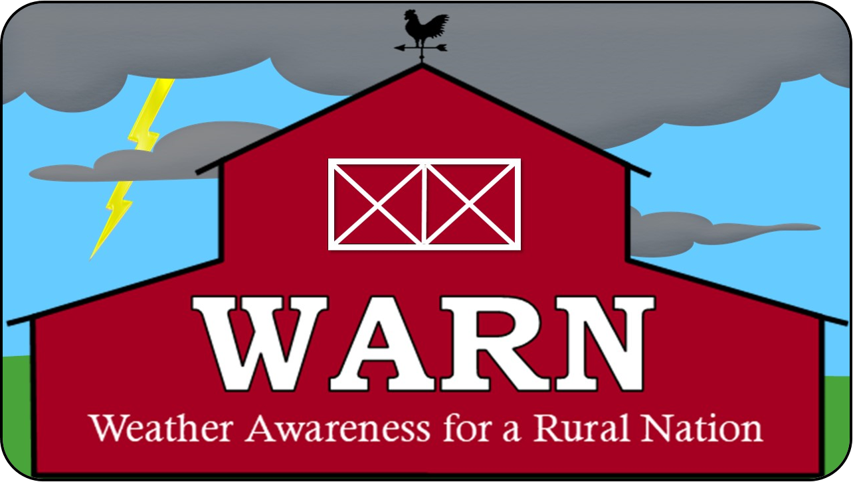

The 2023-2024 Winter Outlook for Kentucky
Derrick Snyder – National Weather Service, Paducah, KY
As the leaves change colors and fall to the ground, crops are harvested, and tendrils of frost form on plants, conversation often turns to what the coming winter will bring. As we have seen, winter in Kentucky can bring a bit of everything, from ice and snow, to flooding, to bitter cold - even severe weather. Given how variable the weather during the winter can be, is it possible to predict what will happen? Many of us have heard homespun wisdom about ways to predict what an upcoming winter will bring. Some of the more popular ones include how dark the hair of a wooly worm is in the fall, the shape of the seed inside of a persimmon, and counting the number of morning fogs in August. Unfortunately, these tales are not necessarily based in truth. The National Weather Service has a division called the Climate Prediction Center (CPC). The climatologists use historical data and pattern recognition, along with latest trends and observations, to predict a seasonal outlook. This past month, CPC just issued the outlook for the upcoming 2023/2024 Winter Season. So how does it shake out?
The winter outlook compiled by CPC covers the months of December, January, and February. It is not possible to give a day by day forecast of what will happen, but it is possible to forecast whether a region will see a greater chance of above-, below-, or near-normal temperatures and precipitation (rain and melted snow and ice). If there is not a strong signal either way, the outlook will say that a region will have an equal chance of seeing above-, below-, or near-normal temperatures and precipitation. It is important to remember that these outlooks cover a three-month period. Periods of cold weather can occur when above-normal temperatures are favored, and the opposite can happen when below-normal temperatures are favored. The same rule also applies for precipitation.
This year, the United States is entering into a strong El Niño pattern. During El Niño, trade winds weaken in the Pacific Ocean. Warm water is pushed back east, toward the west coast of the Americas.
El Niño means Little Boy in Spanish. South American fishermen first noticed periods of unusually warm water in the Pacific Ocean in the 1600s. The full name they used was El Niño de Navidad, because El Niño typically peaks around December.
El Niño can affect our weather significantly. The warmer waters cause the Pacific jet stream to move south of its neutral position. With this shift, areas in the northern U.S. and Canada are dryer and warmer than usual. But in the U.S. Gulf Coast and Southeast, these periods are wetter than usual and have increased flooding.
In Kentucky, the outlook for this winter slightly favors above-normal temperatures across the entire state. For precipitation, the great majority of the state has an equal chance of seeing above-, below-, or near-normal precipitation. However, across far northern Kentucky, the outlook does slightly favor below-normal precipitation amounts. How will this end up playing out over the winter? – We shall have to wait and see!

Timely Tips

Dr. Les Anderson, Beef Extension Professor, University of Kentucky

Spring-calving cow herd

- If you need to replace cows, consider buying bred heifers in some of the Kentucky Certified Replacement Heifer sales that are being held across the state this month.
- Extend grazing for as long as possible to decrease the amount of stored feed needed.
- Evaluate body condition of cows. Sort thin (less than body condition score 5) cows away from the cow herd and feed to improve their condition. Two and three-year olds may need extra attention now. These cattle can use the extra feed/nutrients.
- Dry cows in good condition can utilize crop residues and lower quality hay now (but don’t let them lose any more body condition). Save higher quality feed until calving time. Keep a good mineral supplement with vitamin A available.
- Contact your herd veterinarian to schedule a pregnancy diagnosis for your cows if you have not already done so. Pregnancy diagnosis can also be accomplished using blood sampling. Several diagnostic labs will analyze the blood samples for pregnancy. Culling decisions should be made prior to winter feeding for best use of feed resources. Consider open, poor-producing, and aged cows as candidates for culling.
- A postweaning feeding period will allow you to put rapid, economical gains on weaned calves, keep them through the fall “runs” and allow you to participate in Kentucky CPH-45 sales. Consider this health and marketing program which is designed for producers which are doing a good job of producing high quality feeder calves.
- Replacement heifers require attention during the winter, too. Weaned heifer calves should gain at an adequate rate to attain their “target” breeding weight (2/3 of their mature weight) by May 1.

Fall-calving herd

- Continue to watch fall-calving cows. Catch up on processing of calves including identification, castration, and vaccinations.
- Cows that have calved need to go to the best pastures now! Help them maintain body condition prior to breeding in December.
- Vaccinate the cows while they are open and prior to the breeding season. Move cows to accumulated pasture or increase feed now. It is best to vaccinate cows 30 days before the breeding season begins.
- Start the breeding season in late November or early December for calving to begin in September. If you are using AI and/or estrous synchronization, get your supplies together now and schedule your technician. Don’t forget Breeding Soundness Evaluations (BSE) on your bulls. Make final selection of replacement heifers now.

General

- Have your hay supply analyzed for nutritive quality and estimate the amount of supplementation needed. Consider purchasing feed now.
- Take soil tests and make fertility adjustments (phosphate, potash, and lime) to your pastures.
- This is a good time to freeze-brand bred yearling heifers and additions to the breeding herd.
- Graze alfalfa this month after a “freeze-down” (24 degrees for a few hours).
- Don’t waste your feed resources. Avoid excessive mud in the feeding area. Hay feeding areas can be constructed by putting rock on geotextile fabric. Feed those large round bales in hay “rings” to avoid waste. Concrete feeding pads could be in your long-range plans.

One Pot Tortellini

Ingredients:
- 1 pound lean ground beef
- 1 medium onion, chopped
- 1 medium carrot, chopped
- 3 tablespoons minced garlic
- 1 teaspoon dried oregano
- 1 teaspoon Italian seasoning
- 2 (15-ounce) cans no-salt-added tomato sauce
- 1 (8-ounce) package fresh sliced mushrooms
- 4 cups fresh prewashed spinach (remove stems and tear large leaves into pieces)
- 1 (19-ounce) package frozen cheese tortellini
- 1 cup low-moisture, part-skim shredded mozzarella cheese

Directions:
- Wash hands with warm water and soap, scrubbing for at least 20 seconds.
- Gently scrub the onion and carrot with a clean vegetable brush under cool running water before preparing them. Rinse the mushrooms under cold running water, being sure to remove any dirt; pat dry.

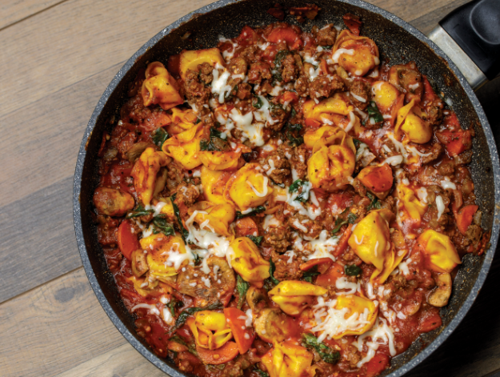

3. Heat a large nonstick pot or skillet over medium heat and add ground beef, onions, and carrots. Cook until ground beef is browned and has reached an internal temperature of 160 degrees F, using a food thermometer.
4. Drain fat from ground beef mixture. Add garlic, oregano, and Italian seasoning; stir until combined.
5. Add the tomato sauce, mushrooms, and spinach. Stir until mixture comes to a boil.
6. Cover with lid and simmer on low for 10 minutes. Remove lid and gently stir in frozen tortellini. Cover and cook tortellini following package directions (usually 2 to 5 minutes).
7. Top with mozzarella cheese and allow to melt before serving.
8. Store leftovers in the refrigerator within 2 hours.

Source: 2022 KYNEP Food and Nutrition Calendar : East Region (4, 6) Nutrition Education Program
340 calories; 10g total fat; 5g saturated fat; 0g trans fat; 65mg cholesterol; 400mg sodium; 36g total carbohydrate; 3g dietary fiber; 8g total sugars; 0g added sugars; 25g protein; 0% Daily Value of vitamin D; 20% Daily Value of calcium; 30% Daily Value of iron; 6% Daily Value of potassium.
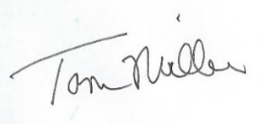
Released by

County Extension Agent for Agriculture and Natural Resources

