Ballard County Ag Newsletter
October 2022

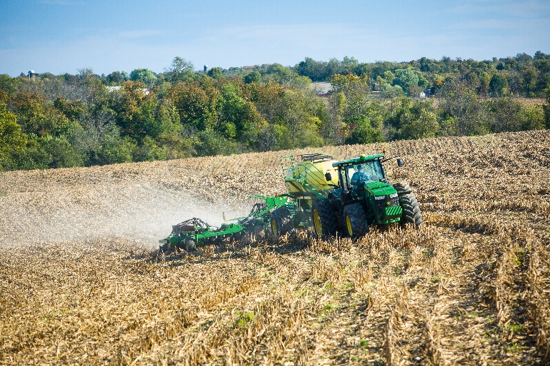

I won’t sound like a broken record in this newsletter because rain will no longer help the soybean crop at all. As harvest winds down, bean yields are following corn yields. Places that got more water had higher bean yields just like corn. I am surprised that some of the beans yielded as well as they did with almost no water the last two months. Single crop beans are running from 40 to 60 bushels per acre with a few 70’s. Double crop beans are 30 to 50 with an average in the lower 40’s.

Commodity prices are still high so this will end up as a marginally good year for most farmers in the county. A few more rain events and we would have had an exceptional year with the good wheat crop we were following. Unfortunately, that is the way of life for a farmer and you all have been through it before.

This year just goes to prove, you can do everything correctly and if we don’t get enough water it

doesn’t matter. We have been extremely lucky in the past 20 + years, with a drought in 2012, areas of drought in 2013, and then this year where the southern part of the county really suffered. The northern side of the county still had very good corn and a little below average beans this year.

Over the time frame our average yields of both corn and beans have greatly increased. I don’t have any data to back this up, but I feel like we grow much better crops on limited rainfall than we used to. No-till corn is not as big of a practice as it used to be but some type of reduced tillage is a much bigger practice and almost completely replaced the conventional tillage of the past. Genetics have gotten better. Planting technology, fertilizer and
Cooperative Extension Service
Ballard County Extension Office
110 Broadway PO Box 237
LaCenter, Kentucky 42056-0237
Phone: 270-665-9118
Email: tmiller@uky.edu
chemical applications have made great strides in efficiency and accuracy. It still comes down to water. If we have enough, yields are great but without it they suffer.

CAIP Program Reminders

I have started getting completed CAIP program forms for reimbursement and I just wanted to give you a few reminders. When you bring me your receipts you must bring some form of proof of payment. Typically this is a copy of the cancelled check but it can be a credit card receipt-- paying cash is not allowed. You must fill out the producer report certification forms. You also need to have the producer education form filled out. Attendance at many different kinds of meetings will qualify so call me to make certain. I am also willing to work one on one with you to fulfill the education requirement so it will not be a hold up.

The final deadline is May of 2023, so you still have plenty of time to get your project done. It might be best to get started now as supply chain disruptions and other factors may make completing your project take much longer than you anticipated.

Wheat Update

Most of the wheat this year was dusted in which is not usually a recommended practice but I think we are going to get by with it. The rain on Tuesday (10/25/22) should help get most of the wheat up. I went out that afternoon and saw wheat that was not emerged that morning already coming through the soil an hour after the rain had ended. We are not out of the woods yet but the extended forecast looks much better and we just need a little rain to get it up and keep it going this time of year.

Wheat and cereal rye are much larger seeds and much more cold tolerant than some of the other grasses we plant in the fall. I am afraid that all the hay we tried to sow this fall will be a failure. One option is to wait until next spring and try again, but weed pressure is usually much more intense in the spring than with fall seeding. Another option might be to plant wheat now. It will give you some spring grazing and you could cut it for hay. Wheat cut in the early boot stage has surprisingly good quality only it is hard to get it dry in the spring. You could then add a summer annual such as pearl millet or sorghum sudangrass and get good grazing or hay in the summer and try reseeding to orchard grass or fescue etc. next fall.

2023 Kentucky Crop Health Conference registration opens Nov. 1

The University of Kentucky College of Agriculture, Food and Environment is committed to educating agricultural industry professionals about integrated pest management. In 2023, UK CAFE will offer the inaugural Kentucky Crop Health Conference. This agricultural pest management event will take place Feb. 9 at the National Corvette Museum in Bowling Green. Registration begins Nov. 1.

Organizers created this premiere grain crops pest management conference for Kentucky farmers, crop consultants and crop production industry representatives. UK CAFE specialists, along with nationally recognized pest management professionals, will offer an in-depth look at the latest research in corn, soybean and wheat crops.

Topics include insect pests, new information on southern rust and tar spot management in corn, and problematic grass weed species such as Italian ryegrass.
“We are extremely excited to bring this premier grain crops pest management conference to Kentucky stakeholders,” said Travis Legleiter, assistant extension professor of weed science in the UK Department of Plant and Soil Sciences. “This conference will provide in-depth knowledge on current and emerging pest management issues in the state. Attendees will be able to use this information to gain an advantage for their pest management programs in 2023.”

Organizers will cap registration at 100 participants, who may earn Kentucky pesticide applicator credits. The conference will begin at 9 a.m. CST and end at 5 p.m., with lunch included. To register, visit https://KentuckyCropHealthConference2023.eventbrite.com or email Jason Travis at jason.travis@uky.edu. Organizers will offer a more detailed agenda closer to the conference date

UK to host Crop Pest Management webinar series

Beginning Nov. 8, the University of Kentucky College of Agriculture, Food and Environment will host a series of five webinars covering field crop protection. Hosted through the Southern Integrated Pest Management Center, the webinars will feature UK extension specialists discussing weed science, plant pathology and entomology.
“These webinars provide the latest grain crop pest management research findings in a convenient and accessible format that is open to everyone,” said Kiersten Wise, webinar presenter and extension plant pathologist. “The presenters are looking forward to providing updates on new or emerging pest management topics and making sure everyone in the agriculture industry has the latest information as they plan for 2023.”
The Tuesday morning webinars will take place via Zoom at 10 a.m. EST/ 9 a.m. CST, and preregistration is required for each webinar. The webinars are open to agriculture and natural resource extension agents as well as agriculture professionals, whether they reside or work in Kentucky or outside the state.
Details and links for preregistration are as follows:
- Nov. 8 - Weed Control Lessons Learned From the 2022 Crop Season with J.D. Green, weed scientist
- https://zoom.us/webinar/register/WN_4JQovXYvR76AZXp_tSmBwg
- Nov. 15 - Managing Important Soilborne Diseases of Soybean in Kentucky with Carl Bradley, extension plant pathologist
- https://zoom.us/webinar/register/WN_t6D6toO8Sh2BhyoD3iw1HQ
- Nov. 22 - Implementing Defensive Shifts Against Problematic Kentucky Weeds with Travis Legleiter, weed scientist
- https://zoom.us/webinar/register/WN_QnugWPJJQUynBXDf4io9zg
- Dec. 6 - Corn Disease Management Questions Asked in 2022 with Kiersten A. Wise, extension plant pathologist
- https://zoom.us/webinar/register/WN_KwibLTsHQY6oJjiKzURCEQ
- Dec. 13 - Entomological Studies in Corn and Soybeans Under Difficult Circumstances (Covid, a Tornado and Drought) in 2022 with Raul Villanueva, extension entomologist

Use this QR code to access direct links to the Crop Pest Management webinars.
Participants may receive one hour per webinar in continuing education units for Certified Crop Advisers. Pesticide applicators can receive one specific continuing education unit in categories 1A and 10 per webinar. Pesticide applicators will receive December webinar credits in January 2023 that will not count toward the 2022 certification deadline. Category 12 no longer requires certification testing or CEUs.
For more information, questions or registration help, contact Jason Travis, UK agricultural extension associate, at 859-562 -2569 or email jason.travis@uky.edu.

Timely Tips
Dr. Les Anderson, Beef Extension Professor, University of Kentucky

Spring-calving herds

- Schedule a pregnancy examination of cows if not done previously. Winter feeding costs can be minimized by eliminating open cows prior to winterfeeding. Pregnancy status (pregnant versus open) can be determined using palpation, transrectal ultrasonography, or blood sampling. Stage of pregnancy can only be determined by palpation or ultrasonography (performed by your veterinarian). A new chute-side blood sampling kit (Alertys from IDEXX) is available for use. It provides yes/no pregnancy data in 15 minutes for about $8 per cow.
- Evaluate the body condition of your cows and improve their condition prior to winter. It takes about 75 pounds to increase body condition a full score.
- If you have already done a preweaning working, revaccinate (booster) calves as needed. Treat calves for internal and external parasites. If you vaccinate calves yourself, be sure to store, handle, and administer vaccines properly.
- Wean calves before cows lose body condition.
- Obtain weaning weights of your calves and remember weaning is the time to do your first round of culling and selecting breeding stock. You can eliminate obviously inferior calves, especially those with wild or nervous dispositions. Consider the number of heifers that you will need to save for your cow herd. Bulls that are old, unsound, roguish, etc. can be culled now. It is not too early to begin thinking about replacements.

Fall-calving herds

- The calving season should be in full swing for fall-calving cows. Check cows frequently. Identify calves and commercial males should be castrated and implanted.
- Take accurate records of calving and calving performance. Our new app (X10D) makes data collection and reporting simple, easy, and convenient.
- Put fall-calving cows on accumulated pasture before the breeding season. Be sure to save some grass in the breeding pastures.
- It is time to get everything ready for the fall-breeding season, too. Line-up semen, supplies, etc. now and get your bulls ready to go (don’t forget their breeding soundness evaluation). Breeding soundness exams are a vital component to reducing the risk of reproductive performance and need to be conducted 30-45 days before EVERY breeding season. Contact your herd veterinarian to schedule the exams.
- Obtain yearling measurements (weight, hip height, scrotal circumference, etc.) on replacement animals - especially for registered ones.
- Contact your herd veterinarian and schedule pelvic area examinations and reproductive tract scores for your potential replacements. Use pelvic area to identify larger heifers with smaller than normal pelvic areas so you can remove them from the breeding pool. Reproductive tract scores can be used to identify immature heifers for culling. Typically, heifers with a reproductive tract score less than 3 have limited ability to conceive early in the breeding season.

Stockers

- If you are purchasing weaned/stressed calves, have your receiving/feeding program in place. Feed a stress ration which contains at least 13% protein and is fairly energy dense.
- Manage to keep newly weaned and/or purchased calves healthy. Calves should be penned in a small lot with adequate feed, water, and shade to reduce stress. Careful handling and comfortable, uncrowded conditions can decrease stress.
- When newly weaned calves are purchased in the fall, sickness and death loss can be a big problem. Work with your veterinarian on a health and receiving program. Consider purchasing CPH-45 feeder calves that are preweaned, vaccinated, bunk-adjusted and treated for parasites.
- Watch calves closely for a few weeks after their arrival. Calves will normally break (get sick) 5-7 days after arrival, but they can break up to 14 days after they arrive. Have a treatment program ready for any health problems. Early recognition of sick cattle improves their chance of recovery. Watch for drooped ears, hollow appearance, reluctance to rise, stiff gait, coughing and dull or sunken eyes. A good “receiving” program is essential to profitability.

General Reminders

- Avoid prussic acid poisoning that can happen when frost ruptures the plant cells in sorghums, sorghum-sudan hybrids, sudangrass, and johnsongrass releasing prussic (hydrocyanic) acid. Fields can be grazed after the plants have dried up after a frost. New growth that occurs in stalk fields is potentially dangerous whether frosted or not.
- Take soil samples for soil analysis to determine pasture fertility needs. Apply phosphate, potash, and lime accordingly.
- Test hay quality and make inventory of hay supplies and needs. Adjust now - buy feed before you run out in the winter.
- Do not harvest or graze alfalfa now in order for it to replenish root reserves.
- Remove fly-control eartags from all animals, dispose of according to instructions on package. Treat for grubs/lice.

Released by

County Extension Agent for Agriculture and Natural Resources

